**BENDY V2**

PAGES / REQUIREMNTS

1. SIGN UP / REGISTRATION

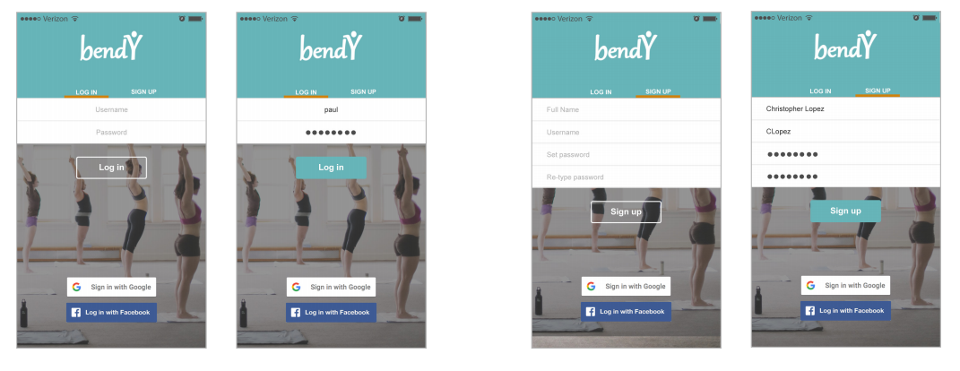

1. ONBOARDING

TBD November/December

1. HOME PAGE (Features/”Discover” from bottom menu)
   1. GROUPS Tab PRIVATES Tab RECOMMENDED Tab

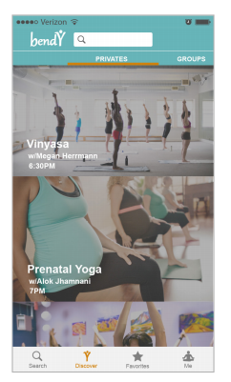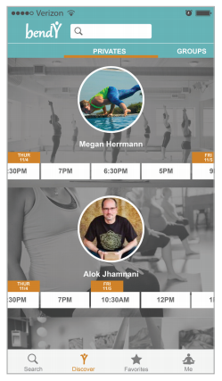 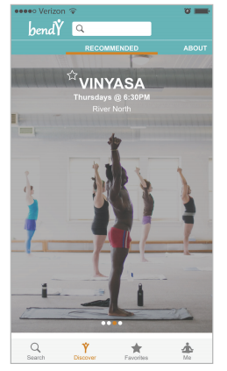

1. ABOUT (From HOME Page)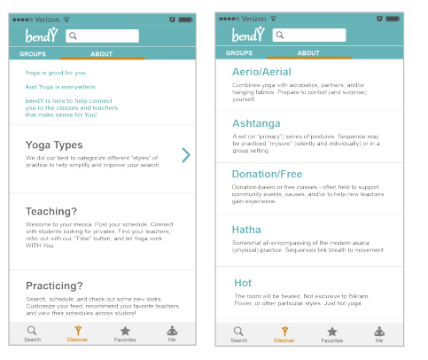
2. CLASS FEED - GROUP CLASSES

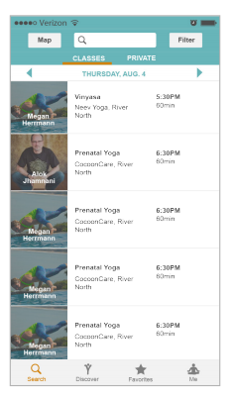

1. PRIVATES FEED

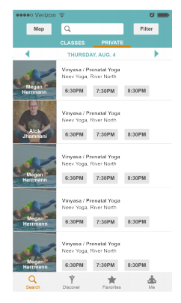

1. SEARCH / FILTER CLASSES (Advanced Search)

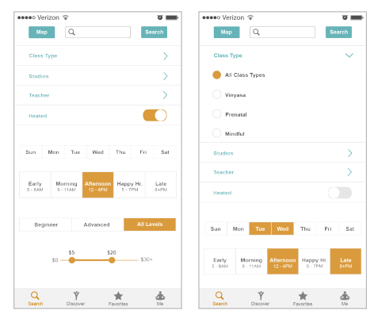 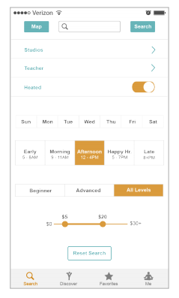

1. MAP VIEW

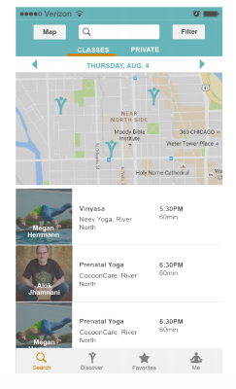

1. CLASS VIEW (DESCRIPTION, ETC)

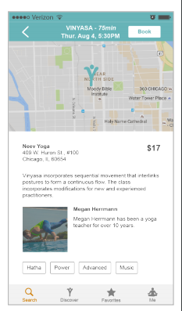

1. BOOK/PAYMENT INFO PAGE (for privates and studio confirmations)
   1. A la salon bookings – like we talked about at 187
   2. Confirmation page included or separate?
   3. Bookings to classes not in studios not associated with mindbody should send teachers and studios confirmation emails
   4. Stripe incorporation
2. TEACHER PROFILE (could mirror Student Profile page, largely)
   1. Displays name, city, #Stars, Bio (with “see more…” so page isn’t crowded)
   2. Includes link to personal website
   3. List of available privates? Toggle view like from class feed?

Request private button to view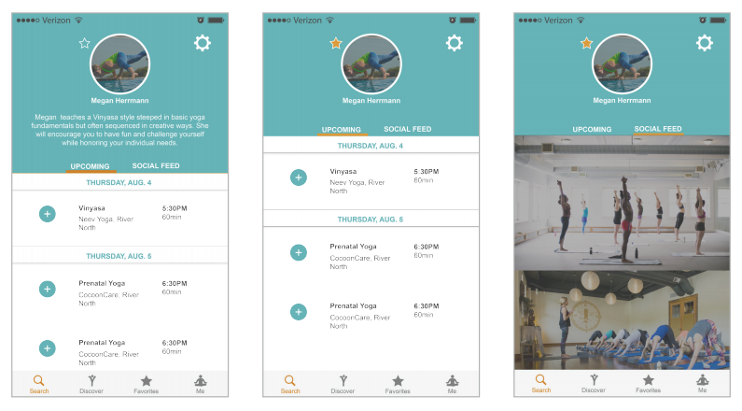

1. REQUEST PRIVATE – Could be the same process as booking a studio class
   1. (from teacher’s profile page or privates feed)
   2. Select preferred time from private availability calendar, list, or other graphic
   3. Ability to input message for details
   4. Teacher notified of request and can view on their schedule page (highlighted to denote different from group classes?)
      1. Ability to accept, decline, add message (message should be required with decline)
   5. Prompts confirmation of appointment/payment form
      1. Student confirms time, price, submits payment
      2. Auto-generated emails to notify parties throughout process
2. STUDENT PROFILE (“MY SCHEDULE”)

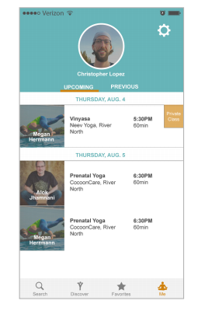with messaging🡪 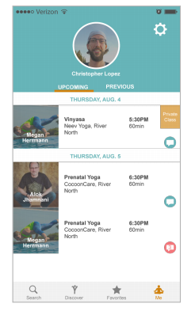

1. TEACHER PROFILE (“MY SCHEDULE”)

Note the difference in shape of orange “Private” bubble from left to right screen – I think the arrow on the right looks better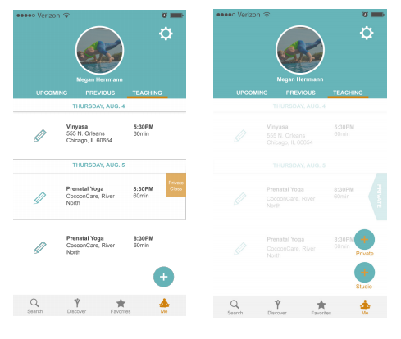

1. ADD / EDIT CLASS

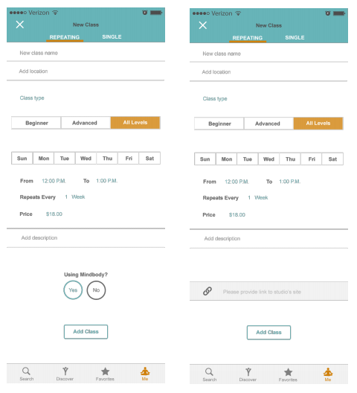

1. TEACHERS’ PRIVATE INSTRUCTION OPT-IN

Still Needed – if we see this differently than adding just adding a private class

* 1. Select weekly time blocks open for privates
  2. Ability to establish/manage recurring time blocks
  3. List rates (optional - maybe rate range?), location conditions (studio, on-demand), specific yoga skills (e.g. injury rehab, trauma-sensitive, beginners, prenatal)
  4. Required Stripe sign-up to take payments
     1. Hover over CC Processing fees/info on how it works via Bendy

1. ACCOUNT MANAGEMENT

Do we also need payment info here?

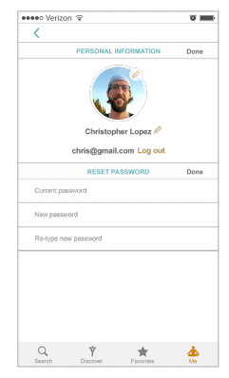

**BENDY V2**

PAGES / REQUIREMNTS

1. SIGN UP / REGISTRATION
   1. Omni Auth for Social (Facebook, LinkedIn?)
      1. Implement emails for joining
      2. Integration with mailchimp for auto emails
   2. Clearer explanations of roll type (student v teacher)
   3. Maybe we don’t force people to sign up right away? We could let them move through the app until they go to sign up? Thoughts?
2. ONBOARDING
   1. Intro carousel slider for help upon registration
   2. Tooltips for content
      1. E.g. hovering over Star icon to reveal “Your Favorites” or “Recommended Instructors”
3. HOME PAGE
   1. Might not be necessary but could be good guider/place to advertise, if user starts here upon signing in / up
   2. Short selection list:
      1. Group Classes
      2. Privates
      3. Featured (people could pay for these spots?)
4. CLASS FEED - GROUP CLASSES
   1. If we don’t have a home page, this is where users could be taken first
   2. Filter button at top
   3. Classes list in chronological order
      1. Separate by days? Or have day scroll at top or bottom?
   4. Each listing should show:
      1. Name of class
      2. Instructor
      3. Studio (instead of weekly/daily repetition like it is now)
      4. Price?
      5. Duration?
      6. Distance from current location – with pin drop or small map icon
   5. Ability to sort classes by Distance or Stars (Recommendations) – I don’t think we need by time as the classes should populate this way no matter what
5. PRIVATES FEED
   1. Same header as group classes but slightly different listings
   2. Request Private button – see “Teacher Profile – Request Private” below
6. SEARCH / FILTER CLASSES
   1. User can click Search or Filter button from Class Feed / Home page / Menu?
   2. We need to separate some of the filter categories, below (and redesign this page to be a little more interactive/user-friendly.
      1. Type (List of specific styles)
         1. Dropdown menu?
      2. Level
         1. Beginner/All Levels/Advanced (select buttons?)
         2. Or: Basic / All Levels / Strong ?
      3. Temperature
         1. Heated/Unheated
      4. Price
         1. (Groupings like it is now or sliding scale)
      5. Time of Day
         1. (Grouping like it is now or sliding scale e.g. ClassPass)
      6. Teacher
         1. Should be an input field to type and search by teacher’s name
      7. Studio?
         1. Not sure if we need to add this here e.g. YogaPanda or not
      8. Location?
         1. Or should this be handled on the main feed
         2. City or specific location – need to be clear where the distance marker drops you
      9. Date?
         1. Or should this be handled on main feed?
7. MAP VIEW
   1. From the Class Feed (and Home page?) user can select
   2. Geolocation pinpoints user’s location and centers it on the map
      1. Currently not intuitive where we’re dropping you
   3. Map should show pin drops of nearby class locations (max #? 20?)
   4. Ability to filter class type from map view? Maybe not necessary?
   5. List of events displayed either below map or upon clicking pin drops
   6. Ability to search by moving the map view (e.g. Yelp) or no?
8. CLASS VIEW (DESCRIPTION, ETC)
   1. User sees this page when they select a class from the Class Feed
   2. Book button
      1. And Add to Phone/Google Cal button? Or should this be automatic?
      2. After users hit book button, they need to be directed to a page with “use this credit card” auto-filled info, or instructed to add a payment method
      3. Class should indicate (hover icon? (e.g. !) whether or not scheduling and payment through Bendy is available
         1. Email confirmation if registered?
         2. Link to studio site if not?
   3. Small map view (for aesthetics) or something to make page pop
      1. Google places?
   4. Teacher info
      1. Profile pic
      2. Name
      3. Star icon + # of stars/recs
   5. Class info
      1. Name of class
      2. Location/studio address
      3. Description (with “See more..” so page doesn’t get too cluttered)
      4. Price
      5. Time
      6. Duration
   6. We can replace “link to sign up” field with the Book button
   7. Tags (search filters) listed
9. BOOK/PAYMENT INFO PAGE
   1. Not yet built out or designed
   2. Confirmation page included or separate?
   3. Bookings to classes not in studios not associated with mindbody should send teachers and studios confirmation emails
   4. Stripe incorporation
10. TEACHER PROFILE
    1. (student or other user’s view, not their own)
    2. User accesses this page by selecting teacher’s name from Class or Privates feed
    3. Created by teacher upon registration, can be edited anytime
    4. Displays name, city, #Stars, Bio (with “see more…” so page isn’t crowded)
    5. Users should be able to click Star (or “Add” button) to add teacher to their favorites feed
    6. Includes link to personal website
    7. List of all currently scheduled classes by date
    8. List of available privates? Toggle view like from class feed?
       1. Request private button to view this?’
11. REQUEST PRIVATE
    1. (from teacher’s profile page or separate page)
    2. Select preferred time from private availability calendar, list, or other graphic
    3. Ability to input message for details
    4. Teacher notified of request and can view on their schedule page (highlighted to denote different from group classes?)
       1. Ability to accept, decline, add message (message should be required with decline)
    5. Prompts confirmation of appointment/payment form
       1. Student confirms time, price, submits payment
       2. Auto-generated emails to notify parties throughout process
12. STUDENT PROFILE (“MY SCHEDULE”)
    1. Users/students can access this to view info, upcoming classes, and history
    2. Basic Profile Info
       1. Picture
       2. Name
       3. City
       4. Stars (link to teachers they’ve recommended, or their Starred feed)
13. TEACHER PROFILE (“MY SCHEDULE”)
    1. Registered teachers /users can access to view info, their scheduled classes, their upcoming attending classes, and history
    2. Basic profile info (see above)
    3. Add Edit/Class button – new page, see 13
    4. Opt In for Privates, new page, see 14
14. ADD / EDIT CLASS
    1. From a teacher’s own profile page
       1. Current “Add Class” not intuitive – could use redesign
       2. Reqs include search filters:
          1. Name
          2. Studio/Location
             1. Need to figure out how people are paying for classes at studios or locations not associated with mindbody
          3. Type, Level, Temp (Heated/Unheated), Price, Time, Duration
       3. Ability to edit individual class without affecting recurring events (e.g. check box that sub will be there, so Bendy removes it from calendar)
          1. Push notification?
15. TEACHERS’ PRIVATE INSTRUCTION OPT-IN
    1. Select weekly time blocks open for privates
    2. Ability to establish/manage recurring time blocks
    3. List rates (optional - maybe rate range?), location conditions (studio, on-demand), specific yoga skills (e.g. injury rehab, trauma-sensitive, beginners, prenatal)
    4. Required Stripe sign-up to take payments
       1. Hover over CC Processing fees/info on how it works via Bendy
16. ACCOUNT MANAGEMENT
    1. Link from Student / Teacher (their own) Profile? Or “Account/Settings” tab in menu?
    2. Users can update their account, profile, payment info and picture
    3. Manage email settings
    4. Remove account
17. MENU
    1. Not currently intuitive – people were getting lost
    2. Schedule could be “My Schedule” or something better
    3. For teachers, “Add/Edit Class” icon could be more prominent
    4. Share via social media
       1. Users can connect social accounts (Fbook, Twitter, Insta) to share they’re attending classes or the bendy platform itself (Invite Others)
    5. Feedback
       1. Users can message Bendy admit to report issues or feedback
          1. Accessible to admins via dashboard
18. MISCELLANEOUS
    1. UI – boxing of info creates noise
    2. Map style is busy
    3. Typeface questions validity of information (we can clean it up)